### Name: __________________________________________ Date: _____________________________

**Rational and Irrational Numbers Notes**

**Today’s Question:** What is the result of the product of a rational and irrational number?

(MCC9-12.N.RN.3)

**Rational Numbers:**

Can be expressed as the quotient of two integers (i.e. a [fraction](http://www.mathwarehouse.com/fractions/)) with a denominator that is not zero.

Many people are surprised to know that a repeating decimal is a rational number.

Examples: -5, 0, 7, 3/2, 

* is rational - you can simplify the square root to 3 which is the quotient of the integers 3 and 1.

**Irrational Numbers:**

Can’t be expressed as the quotient of two integers (i.e. a [fraction](http://www.mathwarehouse.com/fractions/)) such that the denominator is not zero.

Examples: ,,

Now, we want to investigate when you add or multiply rationals with rationals, rationals with irrationals, and irrationals with irrationals to see what the result will be.

Complete the addition table. Complete the multiplication table.

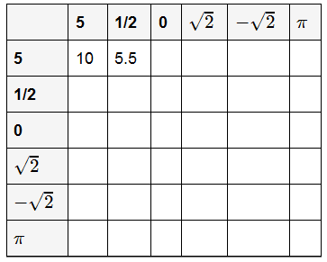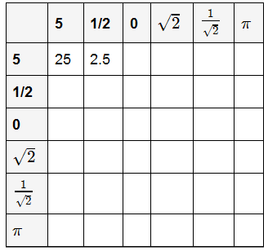

Based on the above information, conjecture which of the statements is ALWAYS true, which is SOMETIMES true, and which is NEVER true?

* 1. The sum of a rational number and a rational number is rational.
  2. The sum of a rational number and an irrational number is irrational.
  3. The sum of an irrational number and an irrational number is irrational.
  4. The product of a rational number and a rational number is rational.
  5. The product of a nonzero rational number and an irrational number is irrational.
  6. The product of an irrational number and an irrational number is irrational.