### Name: __________________________________________ Date: _____________________________

1. Identify the Five-Number Summary number for the data of Johnny’s test scores and draw the Box & Whisker plot.

92, 96, 97, 83, 92, 58, 93, 88, 77, 48, 65, 80, 71

What is the range? ____ IQR? _____ MAD? _______

Are there any outliers in the data set?

1. The table gives the low temperatures in Chicago on eight randomly selected winter days. Which measure of central tendency probably gives the LEAST ACCURATE prediction of a "typical" low temperature on a Chicago winter day?

|  |  |  |  |  |  |  |  |
| --- | --- | --- | --- | --- | --- | --- | --- |
| **Chicago Lows** | | | | | | | |
| 17 | 25 | 28 | 12 | 16 | 55 | 18 | 22 |

1. Describe the shape of the distribution. Estimate the mean, median and upper and lower quartiles for the data.

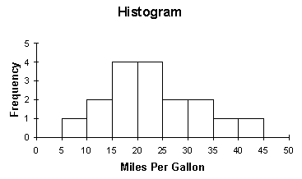

1. Construct a frequency table from the following information:

A survey of 200 9th and 10th graders was given to determine what their favorite subject was. 72 said Math (50 which were freshmen), 38 said Social Studies (20 which were sophomores), and 40 freshmen and 50 sophomores said PE was their favorite.

|  |  |  |  |  |
| --- | --- | --- | --- | --- |
|  |  |  |  | Total |
|  |  |  |  |  |
|  |  |  |  |  |
| Total |  |  |  |  |

Based on your tables above, answer the following questions:

1. What are the marginal relative frequencies in Table 1? ______
2. What are the joint relative frequencies? _____
3. What is the percent that a student surveyed is a freshman? _____
4. What is the percent that a student surveyed likes Math? _____
5. If a student likes Math, what is the percent that they are a freshman?_____
6. For the given scatter plot, find the equation for the line of best fit by hand.



1. Estimate the correlation coefficient for the following graphs.

  

1. 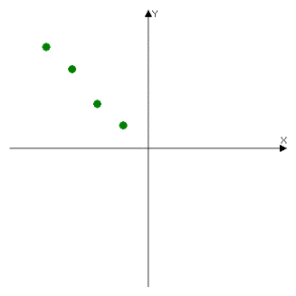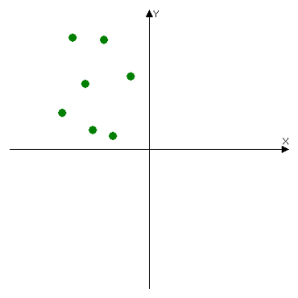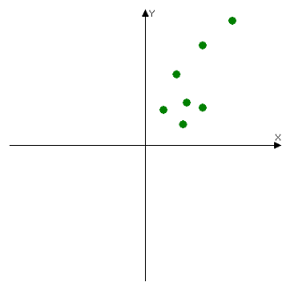 Determine if the following situations represent positive, negative, or no correlation.
2. Number of hours studying for the SAT and your score. ___________
3. The distance you drive and the number of stars in the sky. __________
4. The temperature and the length of daylight hours for the day _________
5. Tell whether the following situations are causation: (yes or no)
6. The number of boats on Lake Allatoona and the number of cars on the street ____
7. The hours you work and the money you make ____
8. The time spent studying and the A on the test _____
9. The following table shows a person study hours versus their test scores.

|  |  |  |  |  |  |  |  |
| --- | --- | --- | --- | --- | --- | --- | --- |
| **Hours studied (x)** | 2 | 5 | 1 | 0 | 4 | 2 | 3 |
| **Grade on test (y)** | 77 | 92 | 70 | 63 | 90 | 75 | 84 |

1. Use your calculator to find the line of best fit for the data above. ________________
2. What is the value of r? _______________________ Is this a good fit? ________________
3. Use the equation to predict the test grade for someone who studies 5.5 hours.
4. Calculate and plot the residuals using the table below. Is there a pattern? Is this a good model?

|  |  |  |
| --- | --- | --- |
| **Hours Studying** | **Predicted Grade** | **Residual** |
| 0 |  |  |
| 1 |  |  |
| 2 |  |  |
| 2 |  |  |
| 3 |  |  |
| 4 |  |  |
| 5 |  |  |